LOAN RELEASE

Screen Shots

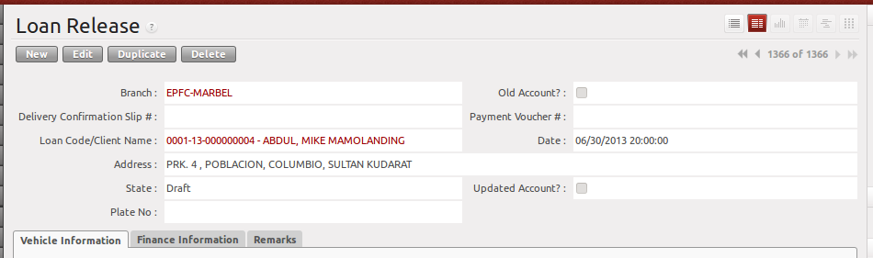
Delivery Confirmation Slip will be automatically filled after filling up of DR Information.

Payment Voucher will be automatically filled after clicking the release button.

Vehicle Information
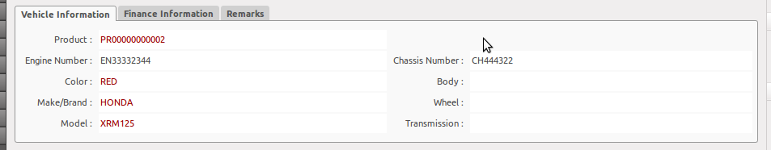
Vehicle Information data is from Purchase Order.

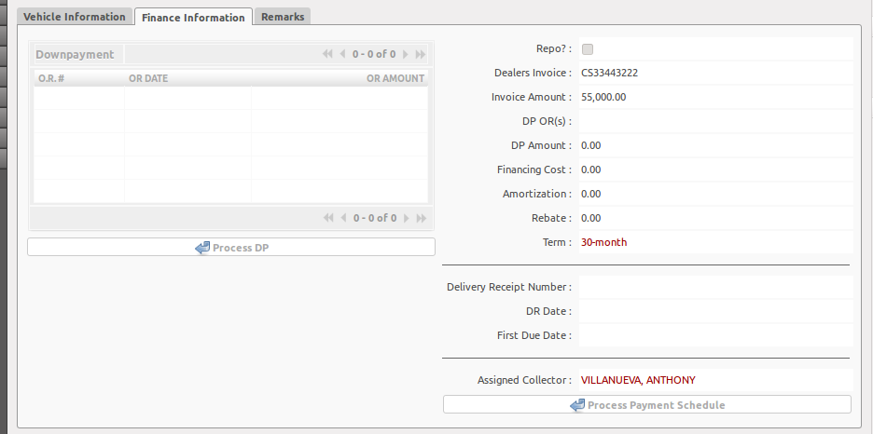
Financing Information

Step 1 → Add the Downpayment OR.
Step 2 → Click the PROCESS DP button. This will validate the Downpayment OR and will compute the final Monthly Amortization.
Step 3 → Input the DR Number and DR Date. The DR Date will be the basis of the First Due Date.
Step 4 → Click the PROCESS PAYMENT SCHEDULE BUTTON.

REMARKS
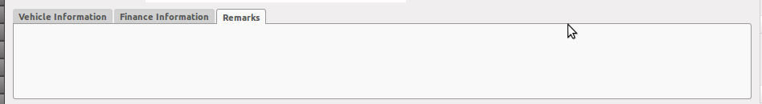

BUTTONS
Release Button
      - this will create a new record to Payment Voucher with its corresponding Journal Entry.
      - This will change the status to “Released”

Cancel Loan Application
      - Cancels loan Application (Not clearly defined yet)

Validations
- You cannot create a new record by clicking the NEW Button. Adding new record will be from Purchase Order
- Release button will not proceed if First Due Date is not computed by the system.
- Release button will not proceed if Payment Schedule is empty.
- If the First Due Date falls from 26th to 31st of the month, it will forward the first due date to the 1st day of net month.
- Downpayment should be greater than or equal to the minimum downpayment.

